From Personal to Professional:
5 Aromatherapy Paths for
Greater Health, Well-Being and Income
Which one is right for YOU?

by Liz Fulcher, RA, CA
Clinical Aromatherapist, Essential Oil Educator
…and one who has tried them all!

AromaticWisdomInstitute.com

Copyright 2014 by Liz Fulcher
All Rights Reserved

No part of this ebook may be reproduced or transmitted in any form or by any means electronic or mechanical, including photocopying, recording or by any information storage and retrieval systems, without written consent from the author except for the inclusion of brief quotations in review.

Liz Fulcher, RA
Clinical Aromatherapist, Essential Oil Educator

I bring over 23 years of essential oil experience, research and education to my work as a Clinical Aromatherapist and Essential Oil Educator.
My greatest joy is in empowering others to become creatively inspired by essential oils, and to follow their dream of becoming successful Aromatherapists!
I’m a former faculty member of the Mt. Nittany Institute of Natural Health in State College, PA where I was Director of Aromatherapy Studies for over 10 years. I currently serve as the Pennsylvania Director for the National Association of Holistic Aromatherapy (NAHA.org).
My life is enriched by 2 dazzling sons, 1 mirthful grandson, 1 spoiled pug, 1 ignoble cat and 1 very patient husband.
Let’s Connect!
E-MAIL: liz@aromaticwisdom.com
WEBSITE: AromaticWisdomInstitute.com

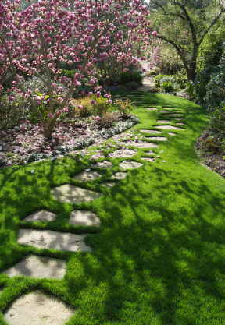

“In the garden of the senses, lies a pathway to the soul.”
-Author unknown

TABLE OF CONTENTS

First Things First... WHAT IS AROMATHERAPY? 1
WHAT IS AN AROMATHERAPIST? 3
PATH #1 THE HOME AND FAMILY AROMATHERAPIST 4
PATH #2 THE ENERGETIC AROMATHERAPIST 7
PATH #3 The Entrepreneur Aromatherapist 8
PATH #4 The Clinical Aromatherapist 9
PATH #5 THE EDUCATOR AROMATHERAPIST 11
GET YOUR AROMATHERAPHY TRAINING 12

First Things First...
WHAT IS AROMATHERAPY?
Aromatherapy is a therapeutic system that uses the essence of certain plants to help you achieve and maintain a healthy body, mind and spirit. You’ll fall in love with this healing modality! Why? Because it can add a whole new dimension to your life - from improving your health to opening the door to a new career. Remember, though only pure essential oils are effective in aromatic healing!

OKAY…SO WHAT ARE ESSENTIAL OILS?
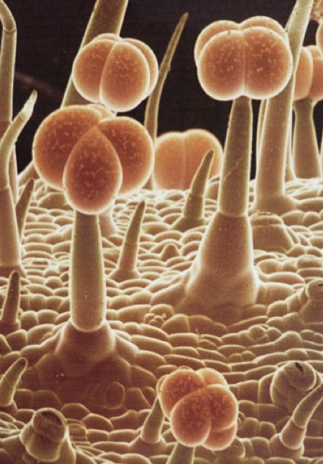
Essential oil glands covering the surface of a Geranium leaf (P. graveolens)
Essential oils come from various parts of plants. Each plant has a specialized gland that creates a liquid which emits the fragrance we come to identify them with. When this aromatic liquid is extracted and bottled, it is called an essential oil.
Despite being called “oils”, these substances are not oily or greasy, but watery. This bottled essential oil is highly concentrated, deeply aromatic and can offer tremendous therapeutic benefits from the physical to the psychological once you understand how to use them properly.

It is important to remember that essential oils are not the same as perfume or fragrance oils. Fragrance oils are synthetic substances created in a laboratory and don’t offer therapeutic benefits. For that you must use pure essential oils!

Try this fun experiment to get acquainted with
essential oils, first hand!
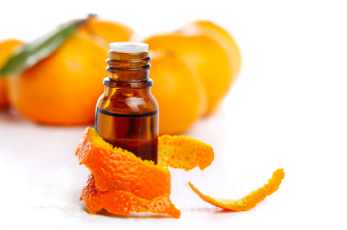

Take a slice of orange rind and hold it up to the light.
Now, bend it in half and squeeeeeeeze! Watch the aromatic liquid as it mists out. That, my friends, is pure essential oil shooting out from glands that are deep in the orange peel!

These glands are found not only in the peel of citrus plants, but in a variety of plant parts like flower petals, berries, leaves, needles, wood and roots.

The glands vary depending on the plant and how it will be used by that particular botanical.

Mother Nature is quite perfect!

WHAT IS AN AROMATHERAPIST?

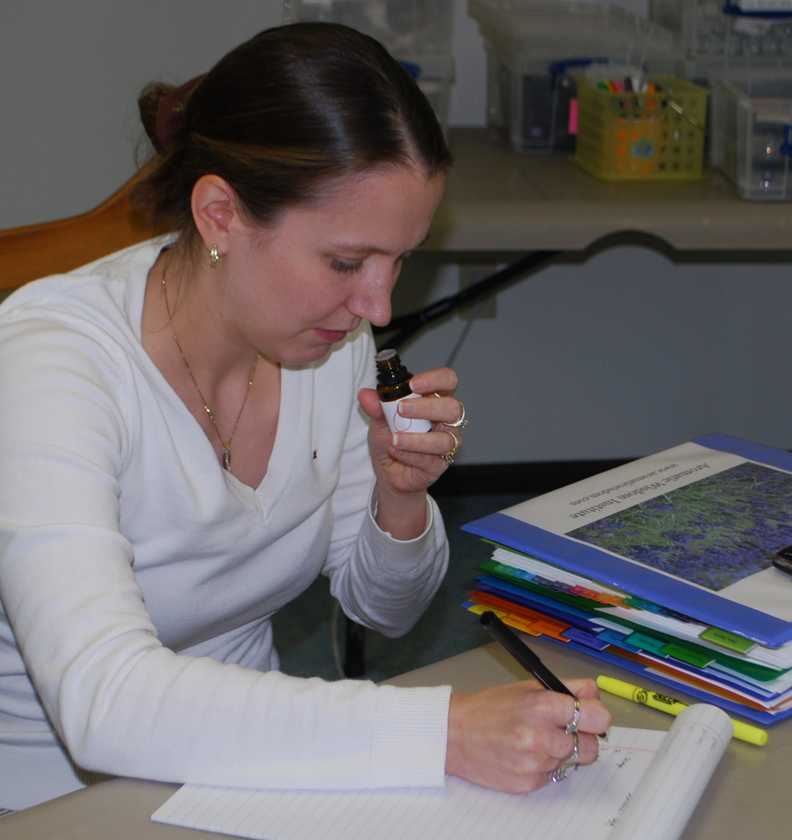

If Aromatherapy is a modality that uses essential oils for healing, then an Aromatherapist is someone who works with and uses essential oils for the purpose of maintaining or improving a situation in a natural way, without chemicals.

Being an Aromatherapist is rewarding, fun and can become an amazing way to make a profitable career!

WHAT CAN I DO WITH AN AROMATHERAPY EDUCATION?

A LOT! You can use your knowledge of essential oils for your own personal healing or to create a whole new career for yourself. You are limited only by your imagination!
Once you experience essential oils and discover how they can contribute to your life in SO many ways, you’ll want to keep trying new oils, adding to your collection, and learning more about their many benefits!

In the next few chapters we’ll take a look at some of the ways an education in using essential oils can enrich your life, and even lead to an interesting new career!

PATH #1
THE HOME AND FAMILY AROMATHERAPIST
With essential oils, you can make a huge long-term impact on your personal health and well-being and that of your family. Not everyone has to make aromatherapy a professional career!
The Home and Family Aromatherapist uses essential oils to support a natural lifestyle as free of chemicals as possible. This kind of Aromatherapist may use essential oils for themselves or include their family and friends. In addition, they use natural aromatics to keep the home clean without using toxic commercial cleaners.

How Essential Oils are Used by the Home and Family Aromatherapist
- Be Prepared with Natural, Effective First Aid
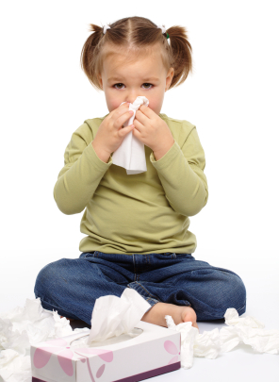

With only a few essential oils in your first aid cabinet, you can address a multitude of daily challenges like muscle pain and inflammation, cold & flu discomfort, headache, fussy baby, sore throat, insomnia and so much more!

Home first aid use is easy since these aromatics can be very effective with just two ways of using them: topically or by inhalation. They can be applied in a compress, spray, and bath or by simply massaging them into the skin.

Essential oils are such a big part of our family that when my grandson was three, he asked for Lavender after receiving a shot from his doctor!
- Manage Emotional Ups and Downs
Everyone experiences stress, anxiety and depression at some point in their lives. Essential oils have many properties that can help with common emotional turmoil.
When my sons were growing up, essential oils were used to help them feel calm their first day of school and later, focused before a test. As a busy mom and businessperson, I often take a warm bath in the evening with soothingessential oils to help me unwind after a long day.
When my last child left for college, I struggled with the “empty nest” and had bouts of anxiety. Bergamot essential oil was a big help in getting me through that transition
- Create a Personalized Skin Care Program
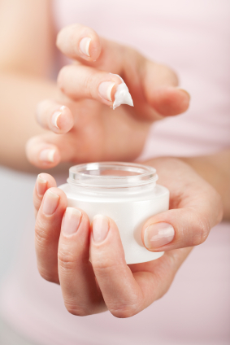
Essential Oils LOVE our skin! There’s no need to spend a fortune on commercial products when you can easily make your own and tailor them to your personal skin type and issues.
You can create blends for acne, wrinkles, eczema, even diaper rash! In my 30s, I developed rosacia and have used palmarosa and frankincense in Jojoba oil for my facial redness, with great results!
- Keep your Home Healthy
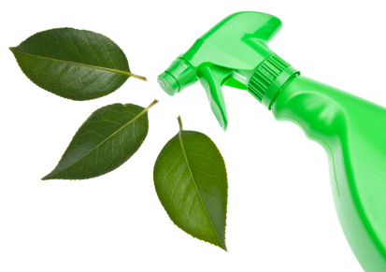
With just a few essential oils like lemon, pine, or lemongrass plus baking soda and vinegar, you can create all the cleaning products you need to keep your home germ-free and smelling great. No more toxic chemicals from commercial cleaners!

Get Started!

At the Aromatic Wisdom Institute, we have three classes that are perfect to get you started on the road to using essential oils in your daily home life:

Therapeutic Uses of Essential Oils

Hydrosols: Aromatic Waters for Healing and Skin Care
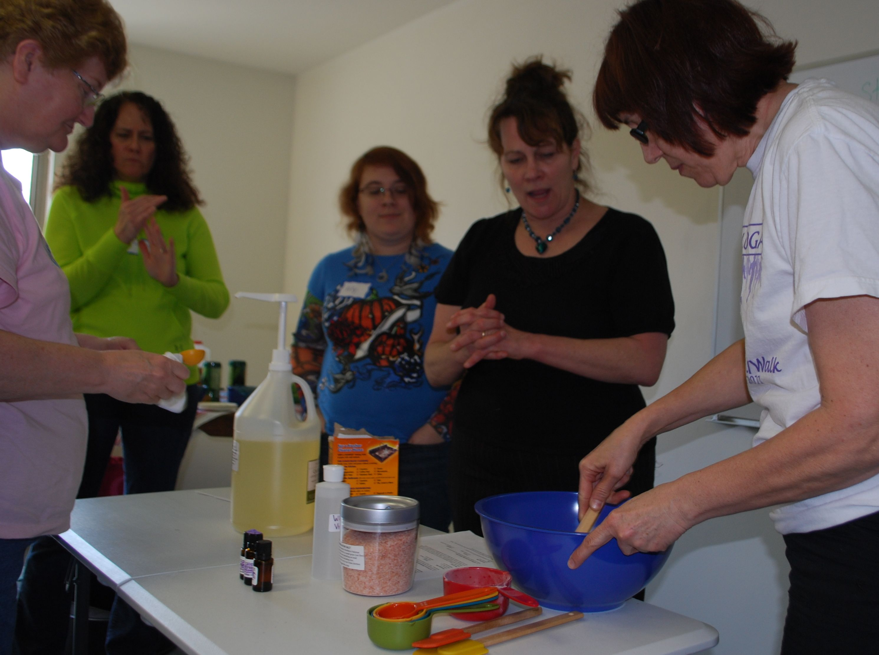
PATH #2
THE ENERGETIC AROMATHERAPIST
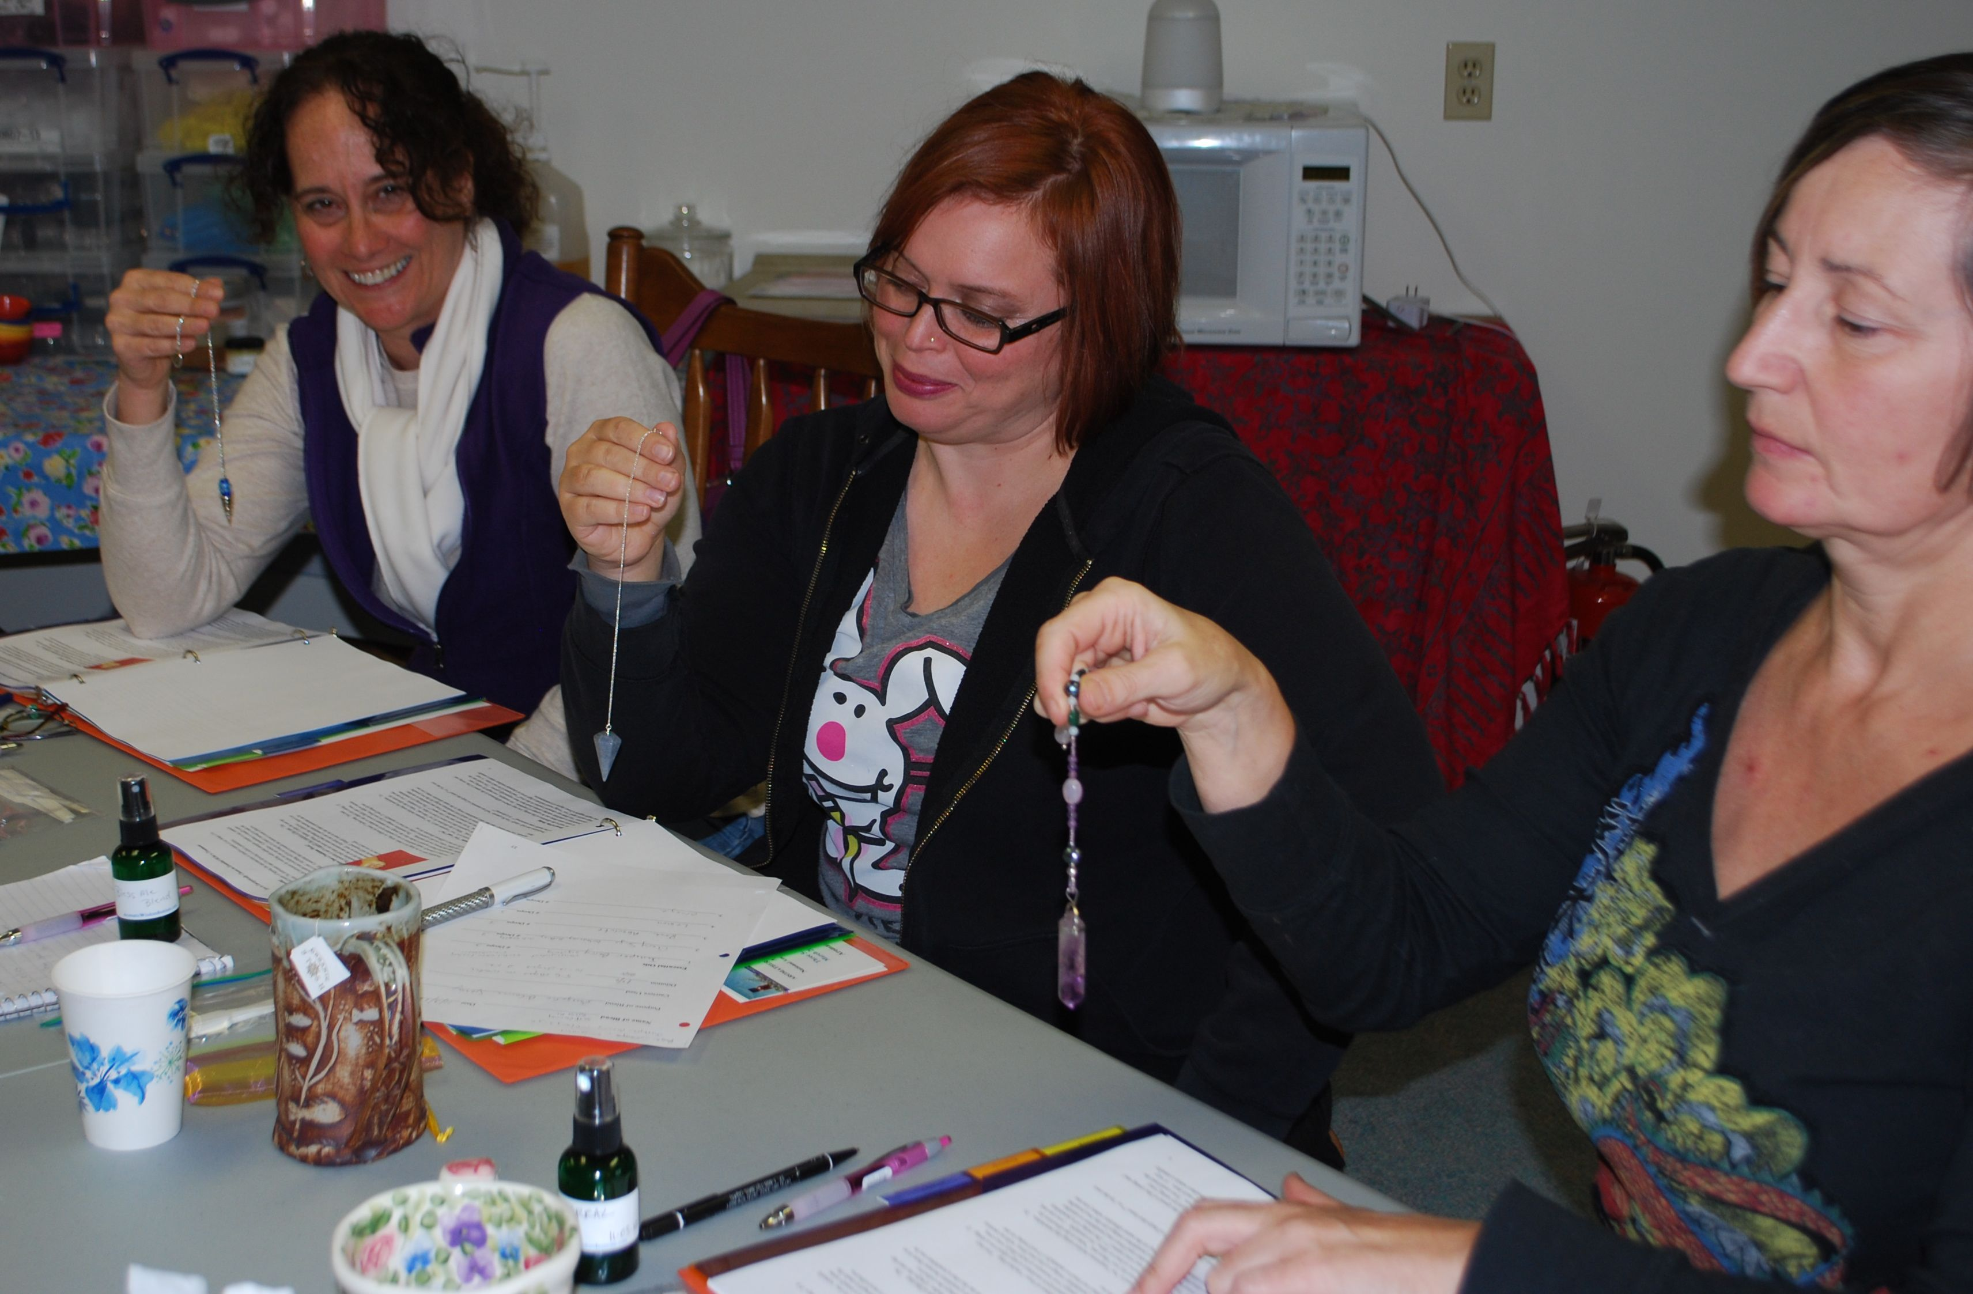
The Energetic Aromatherapist works with the subtle, vibrational qualities of essential oils rather than their physical properties. Their work will embrace the use of essential oils as an aid in meditation, affirmations, visualization and any transformative technique based on inner work.
As an Energetic Aromatherapist, you will work with essential oils primarily in a non-physical way with the intention of affecting subtle energy bodies such as the chakras, as well as the mental, emotion and spiritual aspects of the individual.

Because of the broad nature of “energy”, this Aromatherapist can incorporate essential oils into any setting or profession.

At Aromatic Wisdom Institute we have a very popular class that specializes in how to use subtle energies of essential oils.
Energetics of Essential Oils
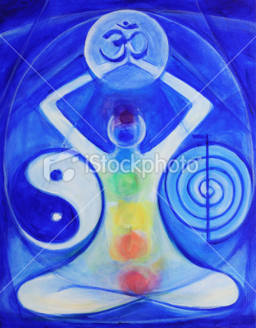

PATH #3
The Entrepreneur Aromatherapist
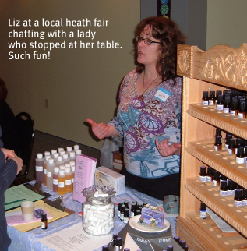

The Aromatherapist with an entrepreneurial spirit can make a very good living working in a retail shop, creating and selling their own products online, offering wholesale products to other practicing therapists or selling natural creations at community craft fairs.

Essential Oil Retail Business
Open your own shop or become a consultant in your local health food store.

Develop your own Therapeutic or Perfume Product Line
Create and sell your own line of products and sell them online. It’s a fabulous at-home business!

Consultation Service
Set up your private aromatherapy practice or join up with a massage therapist, chiropractor, acupuncturist or other holistic service provider.

Sell at Craft Shows
If you like being on the move and working directly with the public, selling your products at craft and health fairs can be lucrative and fun!

If you have the desire to become an Entrepreneur Aromatherapist, we recommend our Aromatherapy Certification Program where we teach the basics of getting started in owning and operating an aromatherapy business.

Aromatherapy Certification Program

PATH #4
The Clinical Aromatherapist
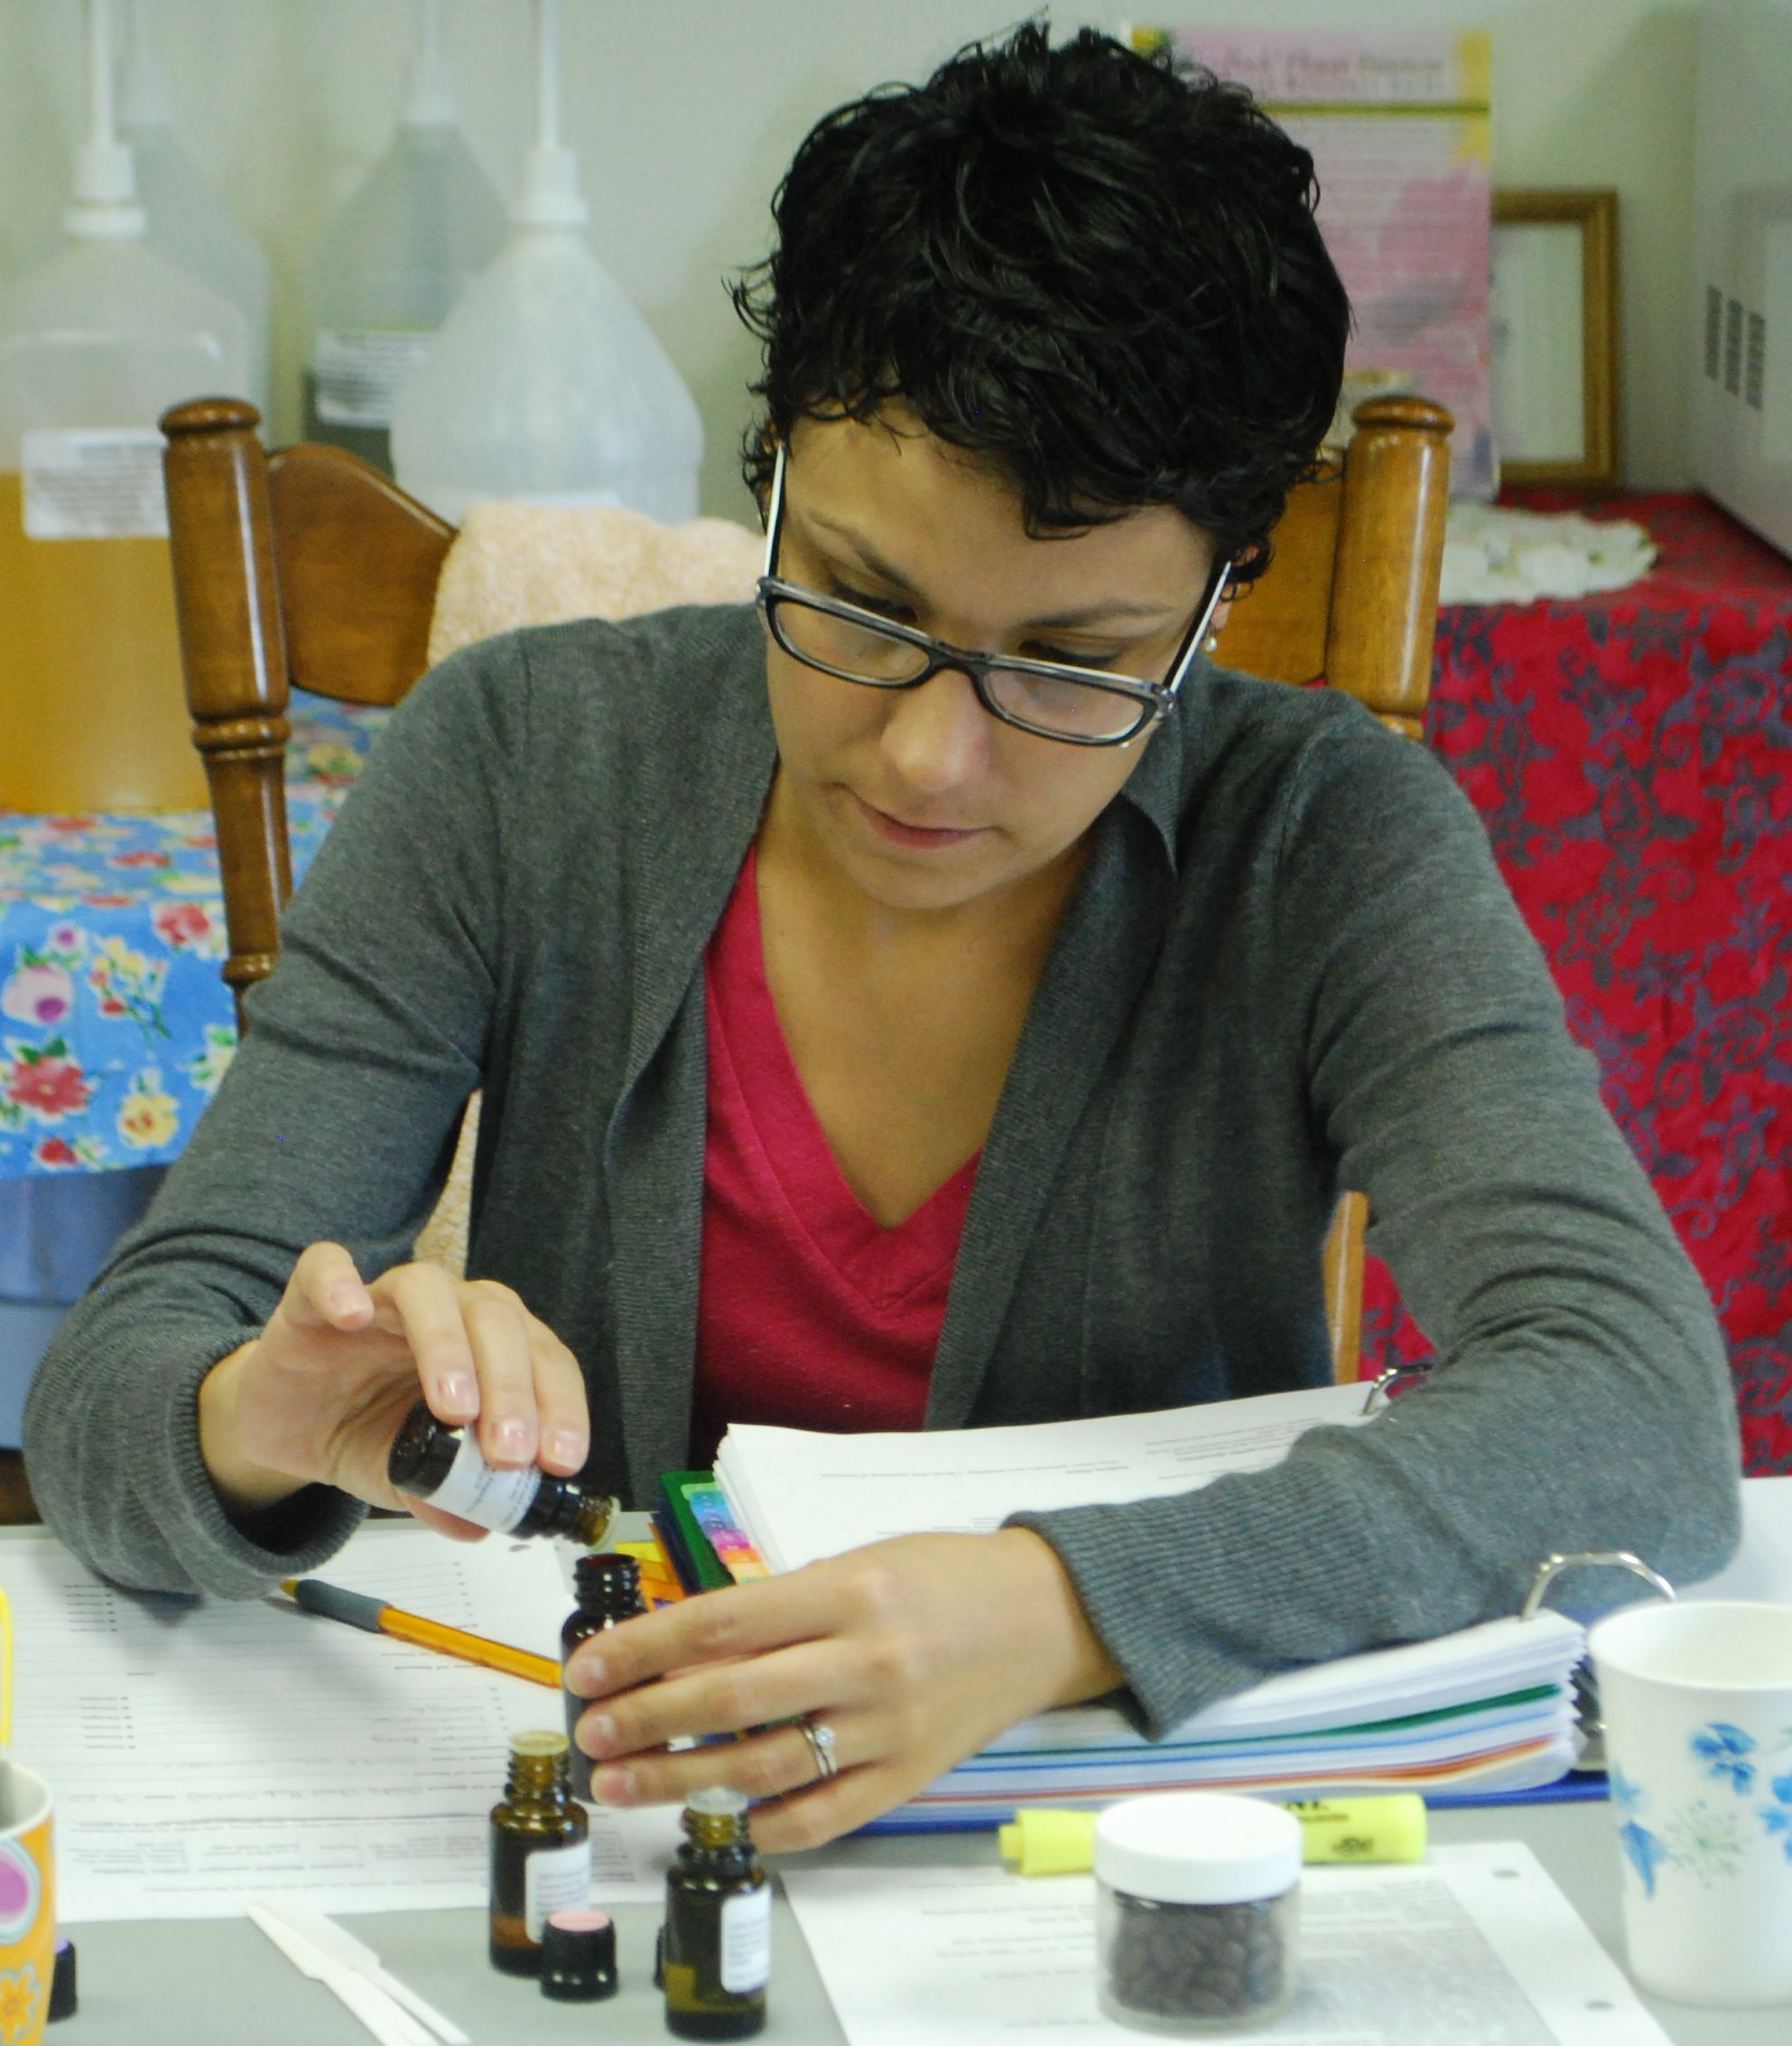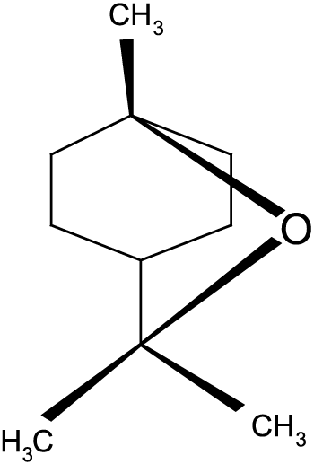

Working with essential oils as a Clinical Aromatherapist is not only exciting, but also very rewarding!
You will personalize formulas from a more targeted perspective and get better results from your blends - a terrific service that will add a unique dimension to your work! In addition, as you deepen your education in the power of essential oils, your credibility as an Essential Oil Practitioner will set you apart from others in your profession. When I began to incorporate essential oils into my work as a Massage Therapist, things changed rapidly in my practice as I had better therapeutic results in my sessions. Plus, I had a renewed love for my work.
Clinical Aromatherapists are trained to use essential oils in a controlled way to get specific results on both physical and psychological levels. You can integrate essential oils into an existing healing practice of massage therapy, nursing, energy work or other allied health profession. Furthermore, if you are in the spa or beauty industry, you can learn to formulate skin and body care products!
At the Aromatic Wisdom Institute, we offer a 235-hour Aromatherapy Certification Program that has been approved by the National Association for Holistic Aromatherapy (www.naha.org). With this comprehensive program, you will get an understanding of 10 basic chemical families and their therapeutic applications, how to conduct a case study, formulate products and blends, how to do a professional consultation and much more! You’ll learn to create effective blends and make over $750 worth of products to take home!

Aromatherapy Certification Program

We have Many Happy Graduates of the
AROMATHERAPY CERTIFICATION PROGRAM!
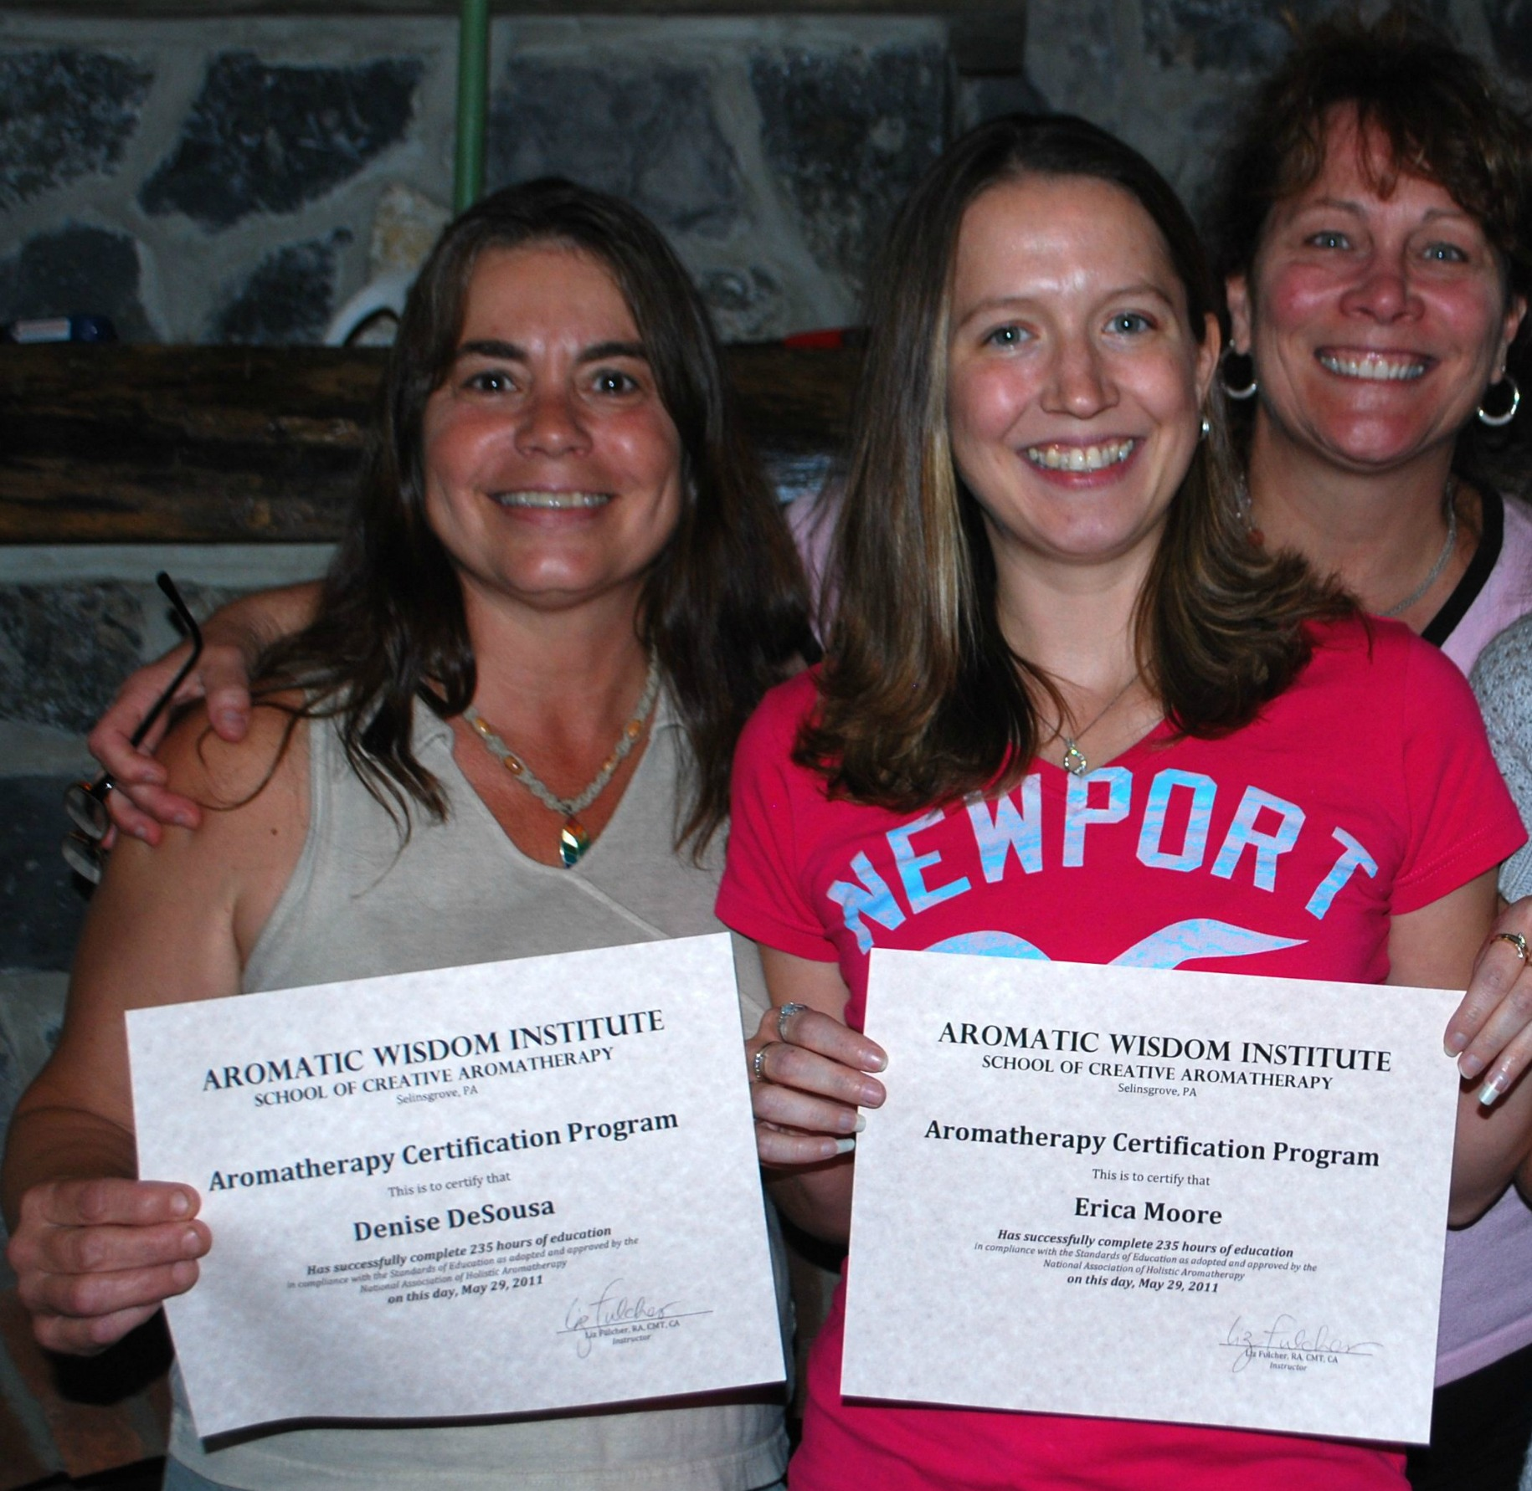

Graduates of our Aromatherapy Certification Program not only incorporate aromatherapy into their personal and professional lives,
but make new friends and are empowered to follow their dreams!

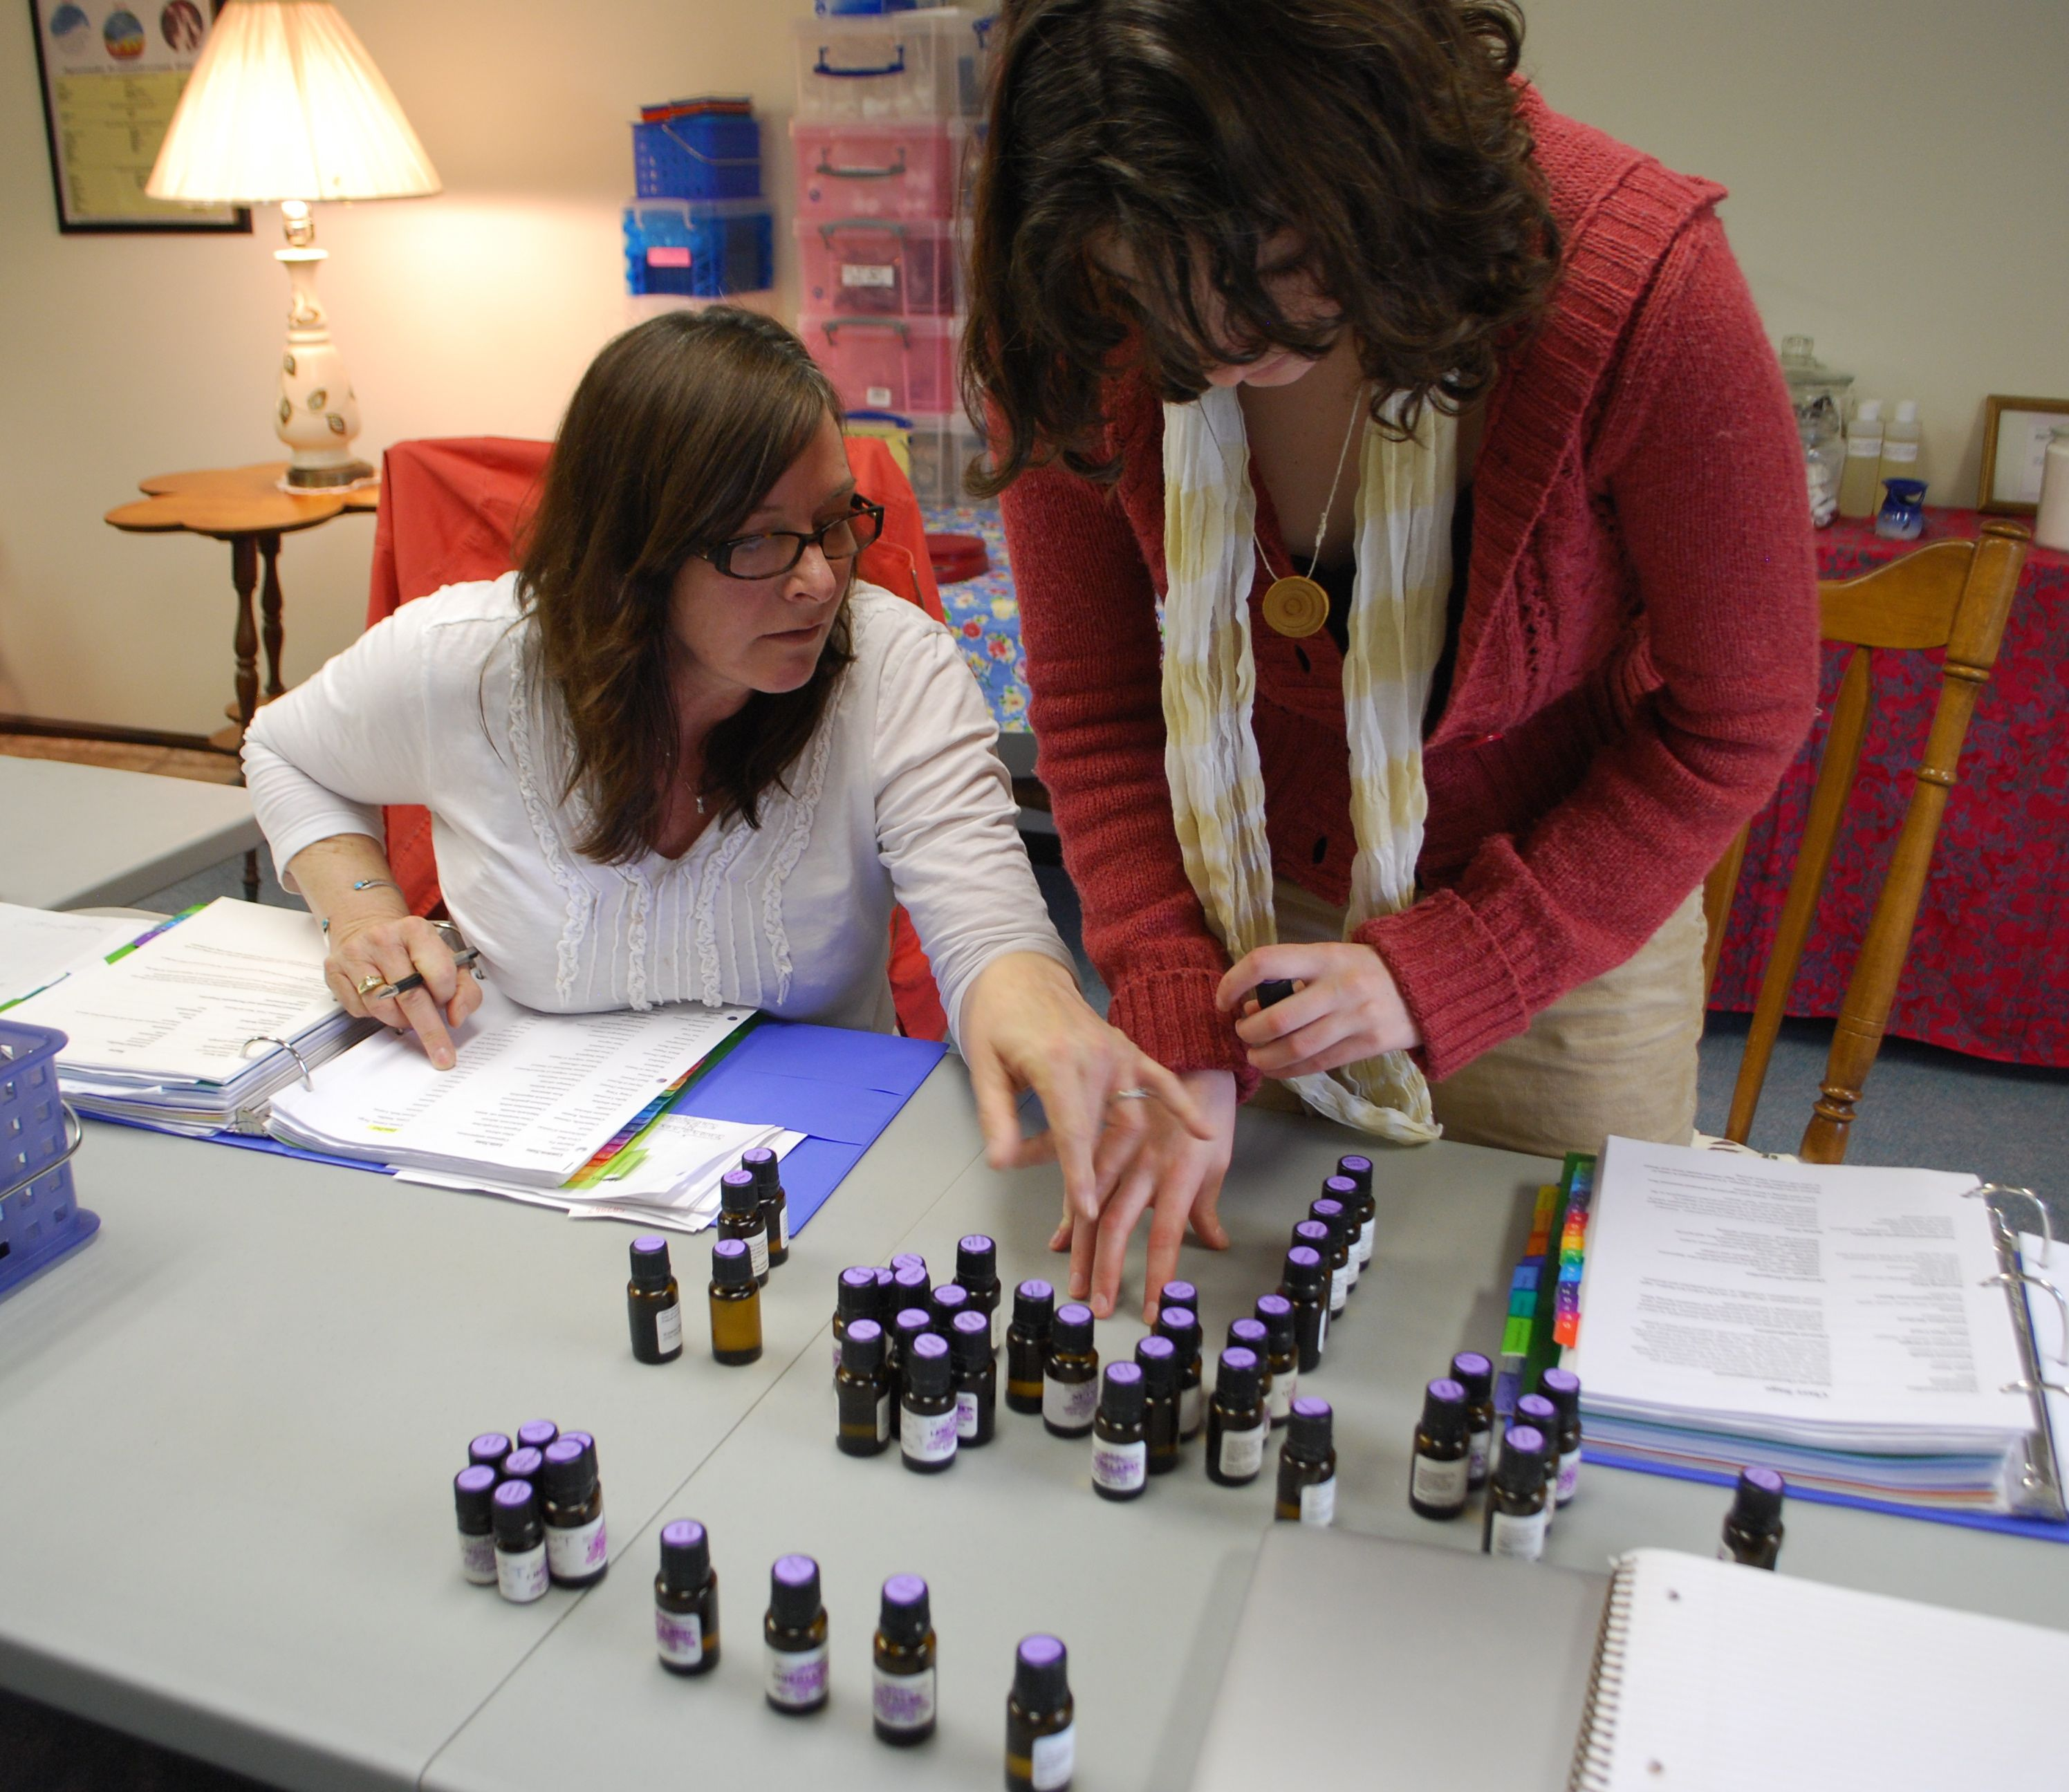
Click here for more information on our Aromatherapy
Certification Program and the dates for our next class!

PATH #5
THE EDUCATOR AROMATHERAPIST
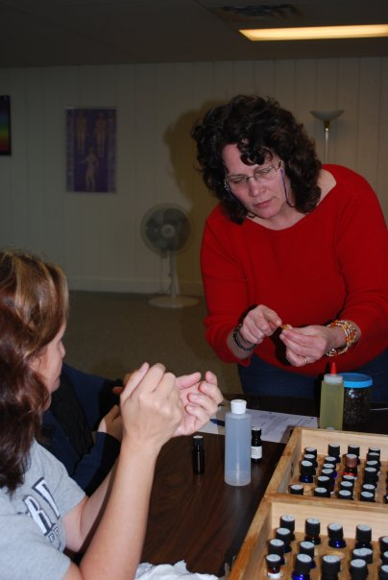
Ahhhh now we’re talking MY language. I LOVE teaching about the many benefits of essential oils!
If you love to explain, teach, write or communicate and you have a love for essential oils, this may be the path for you!
There are many ways to share your love and knowledge f essential oils. You may write a blog offer aromatherapy workshops in massage schools or your local community center. You may even open your own aromatherapy school one day!

Essential Oils will add a satisfying dimension however you choose to apply them to your life.

Aromatic Wisdom Institute is a NAHA-Approved School Provider

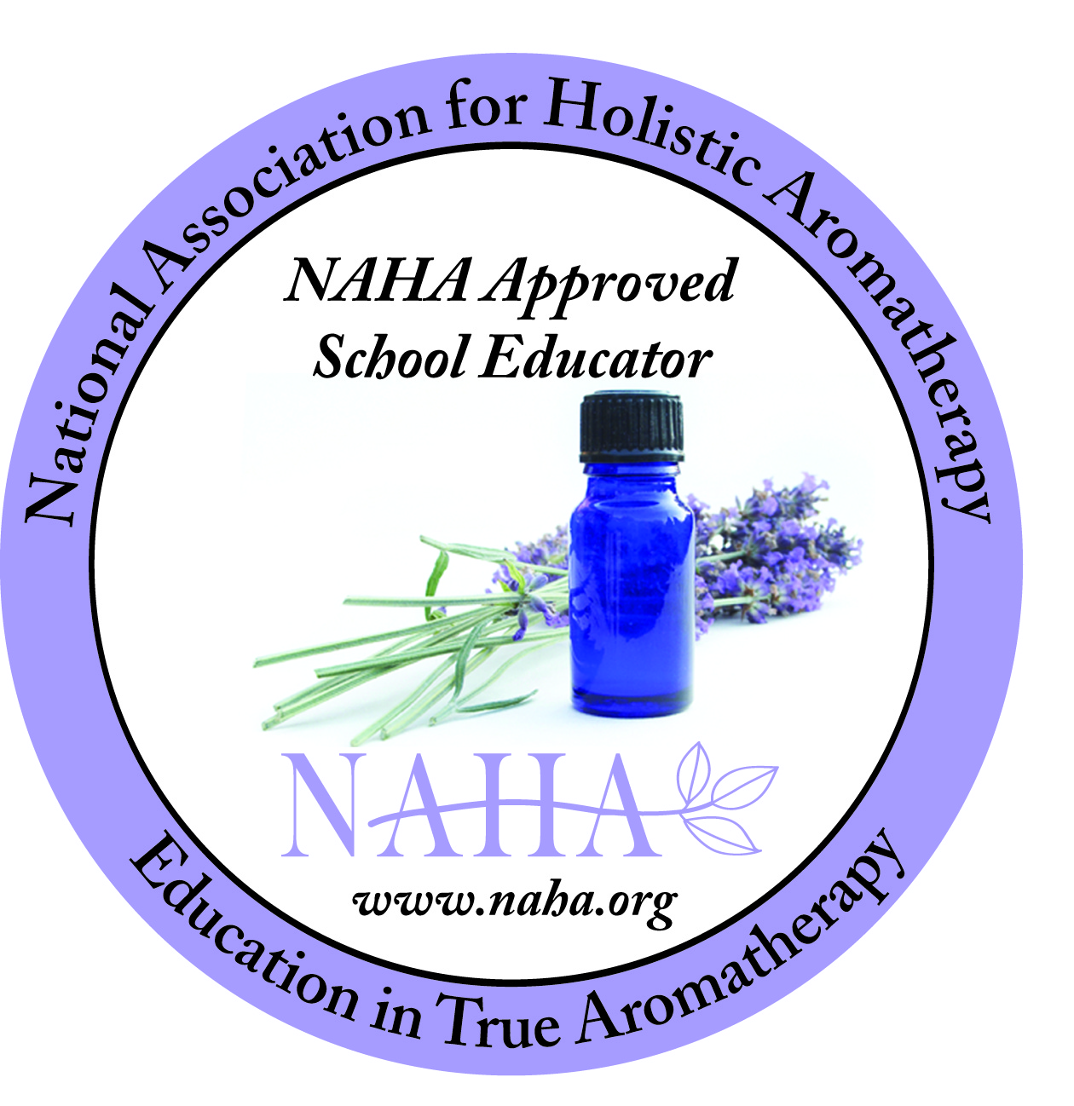
Our Classes

The Therapeutic Uses of Essential Oils
(2 Days)

Hydrosols: Aromatic Waters for Healing and Skin Care
(2 Days)

The Energetics of Essential Oils
(3 Days)

Aromatherapy Certification Program
(15 Days)

Connect with Liz and the Aromatic Wisdom Institute!

